**Computer Vision HW7**

**系級：資工碩一 學號：R07922162 姓名：胡嘉祐**

**There are some function are forked form my hw6 ,such as down sampling, Yokoi number matrix.**

1. **Principle Code and method:**

**Part 1 :Pair Relationship Operator**

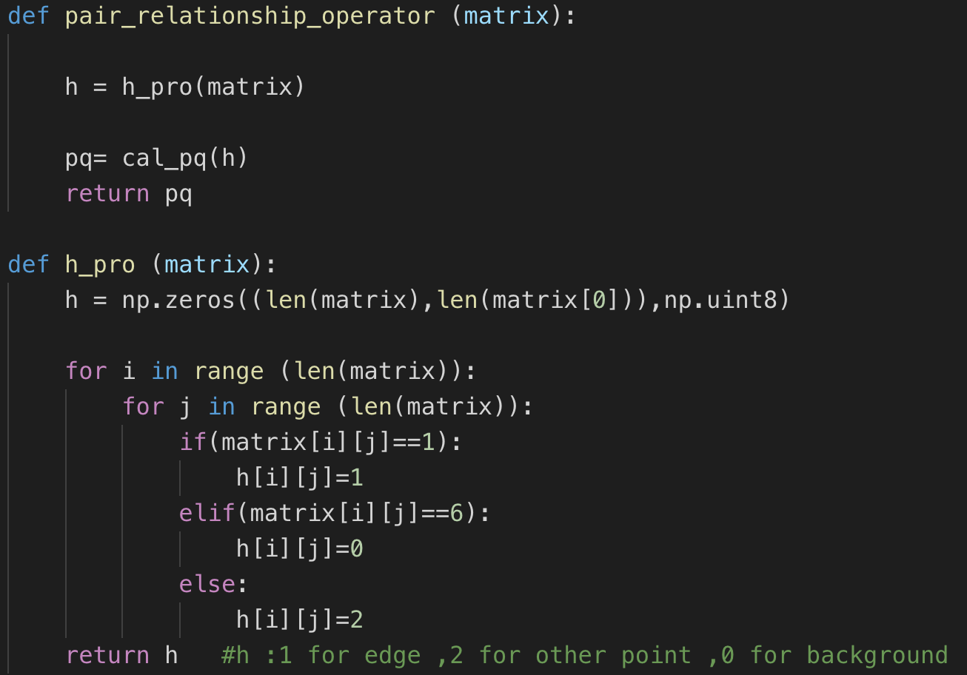

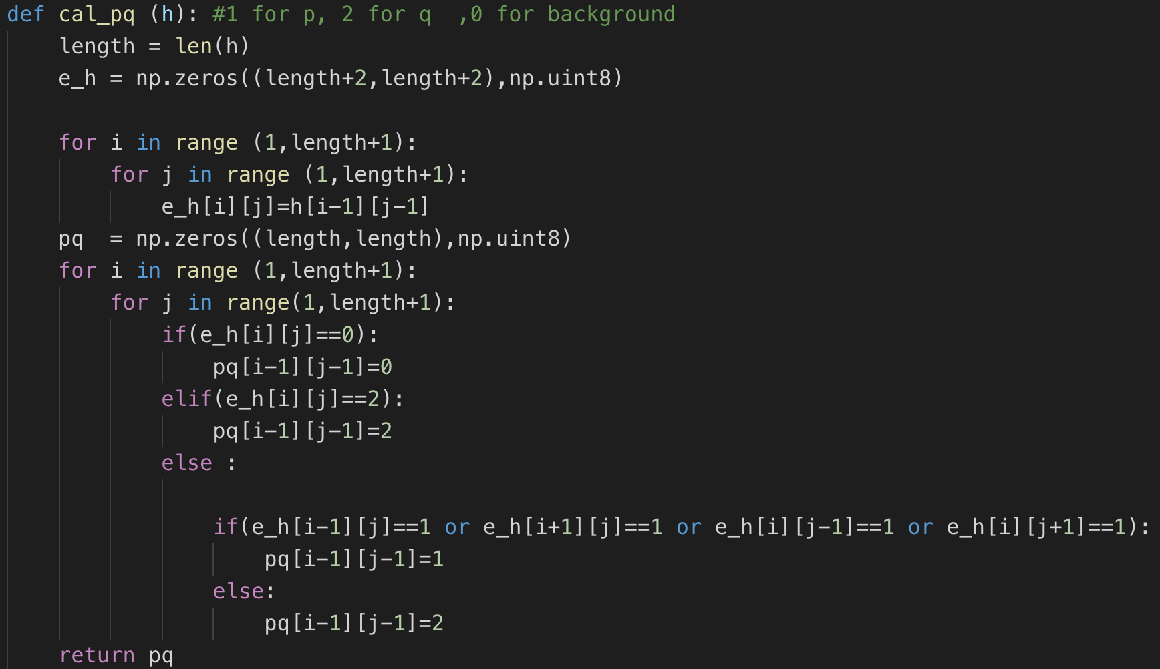

**Part 2: Thinning Operator**

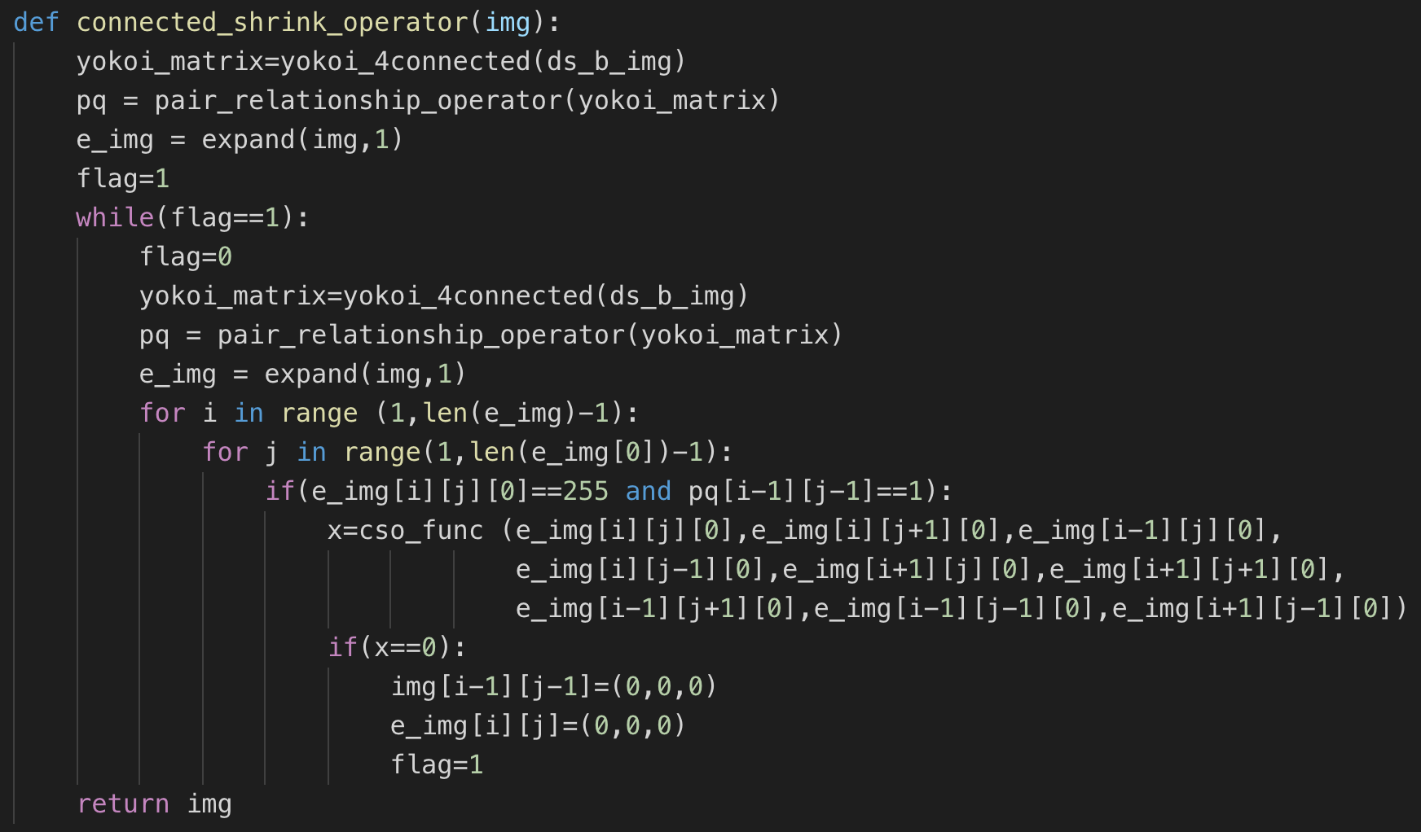

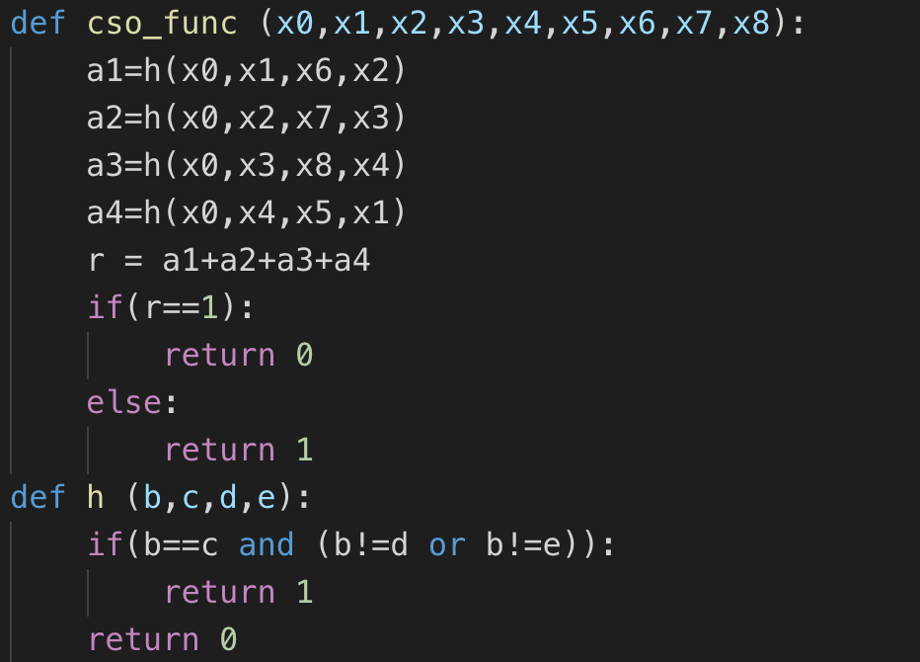

**Main :**

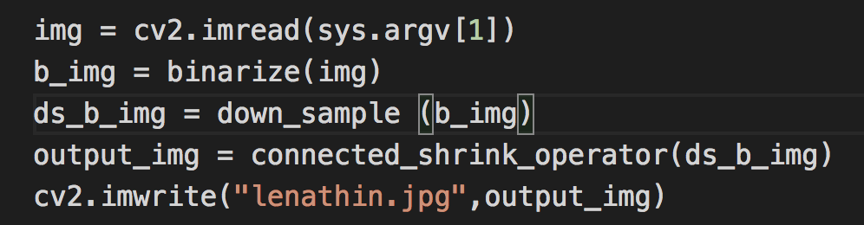

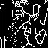**2. Result:**